

ROAD TRAFFIC REGULATION ACT 1984 – SECTION 14(2)

Temporary closure on Path between Fyfield Road

and Queensway, Ongar

NOTICE IS HEREBY GIVEN that from the date specified below, the Essex County Council has temporarily closed to all traffic under Section 14(2) of the Road Traffic Regulation Act 1984, as amended, path between Fyfield Road and Queensway, Ongar in the district of Epping Forest, from its junction with Fyfield Road, west and then northwest to its junction with Queensway.
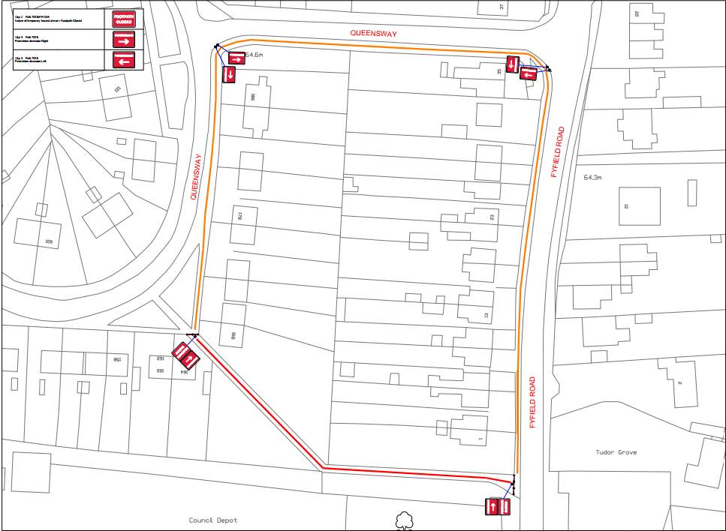
The temporary closure is scheduled to take place on 4 June 2026 to 5 June 2026. The temporary closure is required for the safety of the public and workforce while excavation works are undertaken and transfer services to a lamp column.

The alternative route will be via Queensway, Fyfield Road and vice versa.

Essex County Council
Network Assurance
A2 Annexe, Seax House,
Victoria Road South,
Chelmsford, Essex
CM1 1QH
Telephone: 0345 603 7631 Website: www.essex.gov.uk/highways

DATE 04 June 2026

