
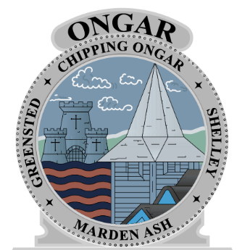
Independent judges will select winners during the second week of December on behalf of
Ongar Town Council
Residents & visitors can vote by filling out a voting card at the Christmas Lights Festival on the Ongar Town Council staff stall or emailing the Town Clerk on clerk@ongartowncouncil.gov.uk
Prizes & certificates will be given to
1st, 2nd & 3rd winners.

BEST DRESSED
SHOP WINDOW FOR CHRISTMAS COMPETITION 2025
Ongar Town Council

